Assessment and Moderation: Key points
There are two major purposes of assessment:
- To improve students’ learning and teachers’ teaching at perscribed levels
- To award qualifications.

There are three types of assessment:
- Diagnostic assessment – occurs at the beginning of learning
- Formative assessment – occurs during learning
- Summative assessment – occurs at the end of a block of study
There are three major purposes of moderation:
- Provides a process for teachers to share student assessment of learning
- To improve consistency of decisions regarding student learning
- To sanction (or not) assessment grades, pre-qualification
There are two types of moderation:
- Internal – performed by peers within your own environment (school/ kura)
- External – performed by specialist peers contracted to NZQA
Establishing your Internal Moderation Model: Best Practice Tips
Considerations | Begin with the end in mind | Tick Box
Manageable | Each stage of the moderation process is clear. Consider a Flow Diagram: See example on reverse side
Accountability | Model in mind of who will want to see it as stakeholders for end use  ERO, Internal Auditors- Tumuaki, BOT, Faculty HOF, others
Quality | Moderation should be actioned by a peer who is proficient in delivering within the same curriculum domain, at the level or above.  NOTE: This may require seeking a moderator outside your own kura.  Contact NZQA for reccomendations of a ‘Best Practice’ provider
Open | The student knows:  - Their learning is in moderation stage  - Moderation has concurred with assessment grade  - Advise student of grade. NEVER before moderation  - Credits have been loaded for transaction to NZQA

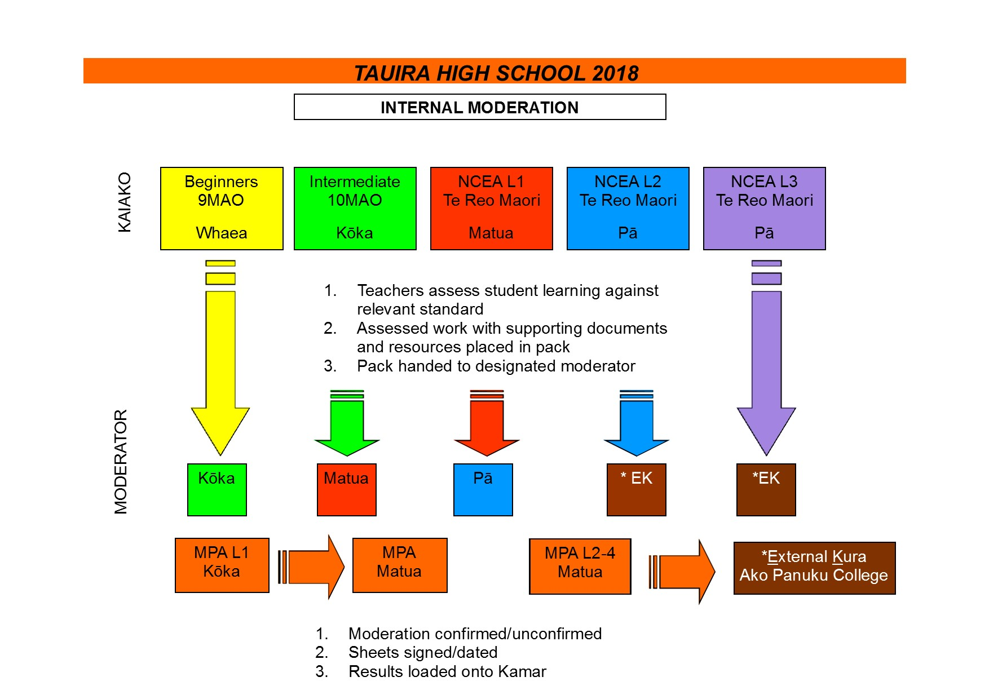

http://assessment.tki.org.nz/Assessment-in-the-classroom/Underlying-principles-of-assessment-for-learning
http://assessment.tki.org.nz/Moderation/Why-moderate

