Different types of plans
Programme Plan  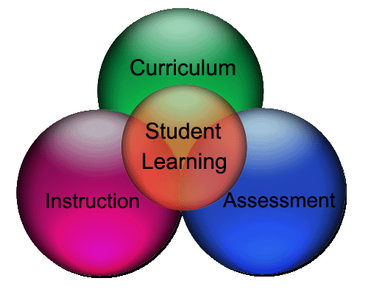 | The purpose of a programme plan is to provide an overview of learning in a subject across year levels. It is a description of the big ideas in a subject and focuses on curriculum progression and pathways. Based on the curriculum, it supports a broad vision and goals that maybe school wide or relate to community, special character, curriculum concepts, competencies and/or values. A programme plan can be presented as a long term plan of 1-3+ years duration and is regularly reviewed. It identifies the range of formative and summative assessments that could be carried out and is usually developed by groups of kaiako, a department or faculty and may involve input by the wider whānau. Te Reo Māori Yrs 11-13 is an example of a programme plan.

Unit Plan | The purpose of a unit plan is to provide detail of the programme plan in action by chunking the learning into time-specific blocks. Unit plans are often centred around a kaupapa and may focus on one particular learning area or strand, or conversely, integrate several learning areas or strands. Unit plans include specific learning outcomes based on achievement objectives/whāinga paetae and identify the type of formative and summative assessments that will be carried out. The duration of a unit plan can range from 2 – 6 weeks or more, and are usually developed by a group of kaiako, or by an individual kaiako. Te Taumāhekeheke o te Ao is an example of a unit plan.

Lesson Plan
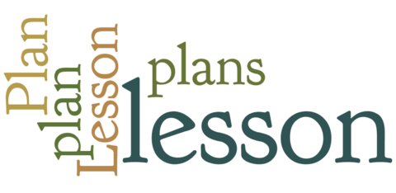 | The purpose of a lesson plan is to provide specific detail of the unit plan in action eg. what will be taught, and how it will be taught. It is a minute-by-minute sequence of actions/interactions intended to achieve a specifc outcome. The specific outcome would derive from an achievement objective/whāinga paetae usually based on a kaupapa within a learning strand. Asking students to reflect on their learning within the lesson may be part of the assessment. Lessons can be 30 minutes to 1 hour in duration and are planned by individual kaiako. An example of a lesson plan may look like this:
Te Reo / Language focus | Te Reo ā-waha
Ara Reo / Modes of language focus | Whakarongo / Kōrero
Āheinga Reo / Purpose | Te tuku me te whakautu pātai
Rautaki whakaako | Kimihia tō hoa

