cid:image005.gif@01CB6AF9.B26426A0

**TE TUHI KŌRERO PAKI**

So you’re writing a story in Te Reo Māori? Ka pai! Here are a few things to help you along:

When writing a story (narrative writing/kōrero paki), the main verbal structure you will be using is:

Ka + verb/kupu mahi (doing word) + kupu ingoa (subject/person/thing)

For example:*Ka titiro a Hēmi ki roto i te rua. (Hēmi looked into the hole.)*

You will also be using the negative form of this:

Kāore ... i …

For example: *Kāore a Hēmi i titiro ki roto i te rua. (Hemi didn’t look into the hole.)*

Here are some things to think about when planning and writing your kōrero paki:

|  |  |  |
| --- | --- | --- |
| ***Kei hea?*** Where is the story based?   * Keep this part short. * Give a basic description of the place so the reader can get a picture in their imagination.   Hei tauira:  *I roto i te ngahere nui o Rauwhānui, ki raro i te maunga o Tihikoi, ko tētahi whare tawhito, he whare mauku, ko tēnei te whare o...* | ***Te wā—*** The time in the past where the story took place.  Hei tauira:  *I te tau*… (In the year …)  *I ngā wā o mua* (In past times …)  *I te wā i a Māui mā* (In the time of Māui and co …) | ***Ko wai*** ***mā?*** Who are the characters in the story?   * Names * Ages * What they look like.   Hei tauira:  *Tērā tētahi tama, ko Neihana tōna ingoa. Tekau mā rima ōna tau. He tama tāroaroa, he tama pūrotu, engari he tino tūpuhi ia.* |
| **Getting the flow going**  Hei tauira:  *I tētahi rā, …* (One day …)  *I tētahi rangi ātaahua*, … (One beautiful day)  *I tētahi rangi makariri*, … (One cold morning) | **He aha te raruraru i ara ake?** What problem arose?  Hei tauira:  *nā te …* (because of the …)  *Kāore ... i pīrangi ki ....* (... didn’t want …)  *Kāore … i ...* (didn’t...)  Use a range of different types of language structures in this part. | **Use a range of connectors to help keep the flow going:**  I muri i tērā, nō muri (After that)  *Ā* (and)  *Nāwai rā, nāwai rā* (After a while)  *Engari* (But)  *Heoi anō* (However)  *Kāore e roa i muri mai* (Not long after)  *Kātahi ka* (Then)  *Koiana te take* (That’s the reason)  *Taro rawa* (Eventually)  *Nō reira, …*  (So,… ) |
| **Saying who said what**  … ko tā … ( … said)  Kātahi ka kī/mea a … (Then … said)  … te kī a … (…said)  Hei tauira:  *“Hōmai tō kete kumara,” ko tā te taipo*. (“Give me your kūmara basket,” the goblin said.) | **Saying when**  I te taenga o … (When … arrived  (on …’s arrival)  Hei tauira:  *I te taenga o te rōpū ki Taranak i* (When the group arrived at Taranaki …)  *I te kitenga o …* (When … saw… )  *I te mutunga o …* (When … finished/on the completion of … )  *I tana taenga ki …* (When he/she arrived at…)  *I tā rāua taenga atu ki…* (When they (2) arrived at …)  *I tā rātou taenga ki …* (When they [3 or more] arrived at …) | **Saying while**  I a …i reira (While … was/were there)  Hei tauira:  *I a rāua i reira* (While they were there)  I a … e …ana (While … were/was …ing)  Hei tauira:  *I a rātou e rere ana, ….* (While they were flying, …) |
| **Pronouns—**when writing a narrative you will often use the following pronouns**:**   * ia (she/he) * rāua (they/them (two) * rātou (them/they (three or more)   **Possesive pronouns**  tāna/tōna/tana  āna/ōna/ana  tā/tō/ā/ō rāua  tā/tō/ā/ō rātou | **Saying ‘think’ or ‘thought’ and idea**  Ka whakaaro a ... (... thought...)  Hei tauira:  *Ka whakaaro a Hēmi mā, me haere rātou ki te whare o te ruanuku*. (Hēmi and the others thought that they should go to the wizard’s house.)  **To think mistakingly – pōhēhē**  *Ka pōhēhē rātou, kei te riu o Kaiahiahi te kāinga o te ruanuku.* (They were mistaken in thinking that the wizard’s home was in the Kaiahiahi valley.)  **To have an idea**  *Ka toko ake te whakaaro i roto i a Hemi.* (Hēmi had an idea.)  *“He whakaaro ōku,” ko tā Hēmi*. (“I have an idea,” said Hēmi.) | **Talking about who had what in the story**  *He pēke pīkau tā Hemi.*  (Hēmi had a back pack.)  *Kāore ā Hēmi pēke pīkau.*  (Hēmi didn’t have a back pack.)  *I ngaro i a ia tana ...* (She/he had lost is/her ...)  *I te mau a Hemi i ētahi rākau mahi atua.* (Hemi was carrying a magic stick.)  *I roto i te kete o te kuia ko ētahi kumara.* (In the old woman’s bag was some kumara.)  *“Kei ahau ētahi māti hei tahu i te ahi,” te kī a Rewi.* (I have some matches to light the fire,” Rewi said.) |
| **Indicating surprise**  *Ka tūmeke rātou.* (They were startled.)  Tūmeke ana rātou i te kaha o te pahū. (*T*hey were startled by the loud explosion.) | **Some other useful structure types**  *i te* (was/were)  *I te tino mataku rātou* (they were very scared)  *Kāore ... i te ...* (wasn’t/weren’t)  *Kāore rātou i te mataku.* (They weren’t scared.)  *He ... (is a ...)*  He ruanuku mōhio ia . (He is a wise wizard.)  *Ehara..*. (isn’t/aren’t)  Ehara ia i te ruanuku mōhio. (He isn’t a wise wizard.) | **Conclusion**  Ka tau tō rātou noho mō ake tonu atu. (They lived happily ever after.)  Ko tērā te mutunga o ngā raruraru o te iwi nei. (This was the last of the people’s troubles.)  Ko tēnei te kōrero mō ... (This is the story of)  Ka mutu i reira ngā raruraru o te iwi nei. (The troubles of the people stopped then.) |

Basic structure of a narrative

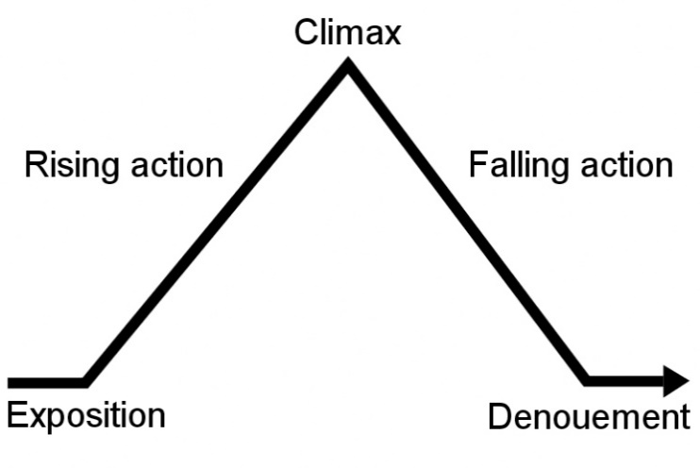Exposition (The exposition is the portion of a [story](http://en.wikipedia.org/wiki/Narrative) that introduces important background information to the audience; for example, information about the setting, events occurring before the main plot, characters' [back stories](http://en.wikipedia.org/wiki/Back_story), etc. Exposition can be conveyed through dialogues, through a character's thoughts, through background details, through [in(universe](http://en.wikipedia.org/wiki/In-universe) media such as newspaper clippings, trial reports and letters, or through a narrator telling a [back(story](http://en.wikipedia.org/wiki/Back-story) or by establishing scenes where a character is followed. Exposition is considered one of four [rhetorical modes](http://en.wikipedia.org/wiki/Rhetorical_modes) of discourse, along with [argumentation](http://en.wikipedia.org/wiki/Argumentation), [description](http://en.wikipedia.org/wiki/Description), and [narration](http://en.wikipedia.org/wiki/Narration). (Wikipedia)

denouement (You know that part of every movie after the big action scene, where things get explained, and the characters tie up loose ends? That's called the denouement, or the showing of how the plot eventually turns out.

Image from: <http://english.learnhub.com/lesson/4579-plot-structure>

Information from: <http://en.wikipedia.org/wiki/Exposition_(narrative)>

# Let’s looks at a story of Māui and the Sun to see this structure at work:

|  |  |
| --- | --- |
| **Exposition** | Māui and his brothers are eating kai. The sun goes down. Māui is frustrated at having to eat kai in the dark. He addresses his people about the selfishness of the sun and that he will force the sun to slow down. The people laugh at him and call him crazy. He convinces them that it is possible. |
| **Rising action** | The next day Māui and his brothers collect flax to make ropes. He taught them special techniques. After five days the ropes were complete and Māui recited a special karakia over them. Māui and his brothers travelled for 12 nights to get to the home of the sun. They built huts from clay to shelter themselves from the heat of the sun. |
| **Climax** | Māui instructed his brothers to capture the sun in the ropes, whilst he attacked the sun with the jaw bone of his grandmother, Muriranga Whenua. The sun questioned Māui, “Why are you doing this?” “We have too little time to complete our work,” Māui replied. “From now on you will travel slowly in the sky.” Tama-nui-te-rā gave up the fight. |
| **Falling action** | Māui instructed his brothers to release the ropes and Tama-nui-te-rā, battered and bruised, began a slow journey through the sky. |
| **Denouement** | The days became longer for Māui and his people, giving them plenty of time to fish, gather food and do their chores. Māui's power and ability could never be questioned again. He had succeeded in taming the sun. From that day until this, Tama-nui-te-rā has always travelled slowly across the sky. And this is the story of how Māui slowed the sun. |

**Use this to plan your kōrero paki.**

Mahere whakaaro – Planning page

|  |
| --- |
| Whakaraupapa haeretia ō whakaaro ki tēnei pouaka  Use this space to brainstorm your answer (and organise your thoughts?) |

Whakarite haeretia ō tuhinga ki tēnei pouaka (Use the planning boxes to write your story)

|  |
| --- |
| Kei hea/ā hea?  Setting – Where and when?  Ko wai ngā tāngata?  People – Who? |

|  |
| --- |
| He aha te tino kaupapa?  Plot/problem/Main theme (What?)  He aha ngā mahi?  Events (What?) |

|  |
| --- |
| He aha ngā rerenga tika, ngā kupu tika?  Key vocabulary and structures. |

**MAKE SURE YOU CHECK THE ASSESSMENT CRITERIA/EVIDENCE STATEMENTS ON THE NZQA WEBSITE.**