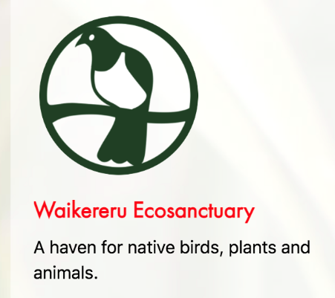
2022 AKO PANUKU PROFESSIONAL LEARNING SUPPORT

Waikereru Wild Lab Tiaki Taiao
Waikereru Ecosanctuary, Gisborne

Designing a Local curriculum with a Local – Global Lens
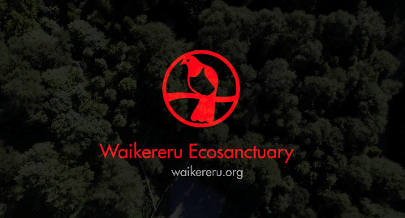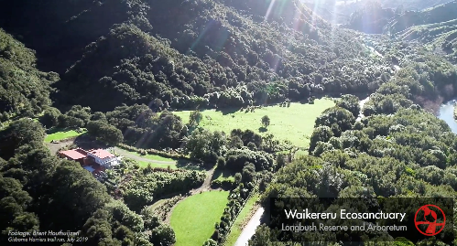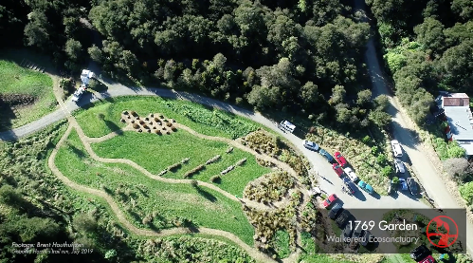
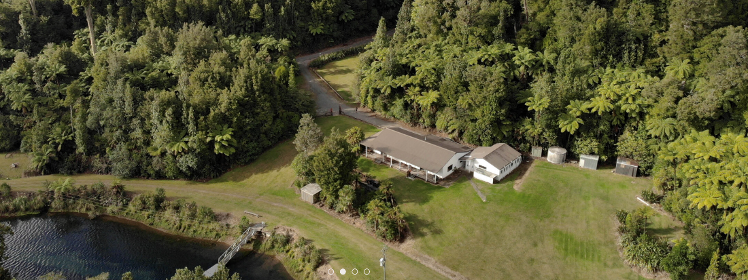

This 2-day workshop inspires kaiako and ākonga in creative, inquiry-based workshops to understand what has happened to local ecosystems since human arrival, and to take part in restoring these to a state of ora (health, well-being).

WHEN AND WHERE:

19-20 September 2022
Waikereru Ecosanctuary, Gisborne

LEARNING OUTCOMES:
- An understanding of ecosystems in our taiao
- Knowledge of ecosystem cycles
- Best practice conditions for restoration projects
- Knowledge of where to find information and support

COURSE FACILITATORS
Anne Marie Vigiant

TRDs AVAILABLE
1 TRD available if participants attend the two full days.

TRAVEL AND ACCOMMODATION
Ako Panuku will provide travel and accommodation assistance for this course if your registration is received at least 3 weeks prior to the start date of this course. If we receive your registration within 3 weeks of the course starting date you will be responsible for your own travel and accommodation arrangements.

